CHAPTER 5

INPUT OUTPUT INTERFACES

8259A PROGRAMMABLE INTERRUPT CONTROLLER (PIC)

Block Diagram
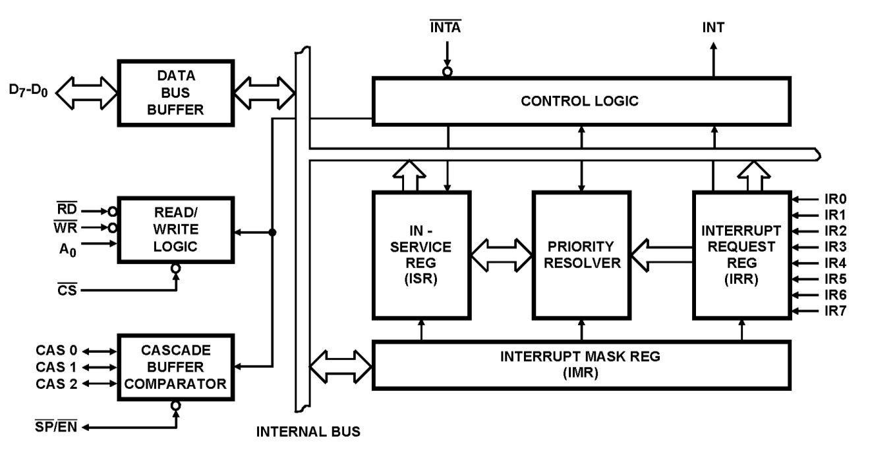

Data Bus Buffer

- This tri-state, bidirectional 8-bit buffer is used to interface 8259A with the system data bus

- Control words and status information are transferred through data bus buffer.

Read/Write Control Logic

- The function of this block is to accept commands from CPU and control the device.

- It contains the initialization command word register (ICW) and operational command word register (OCW) to store various control formats for device operation.

- It has the following control signals-
CS(Chip Select): A low on this input enables the 8259A.
WR(Write): A low on this input enables the CPU to write control words to 8259A.

̅̅̅̅RD (Read): A low on this input enables 8259A to send its status to the CPU.
A₀: This line is connected to address line A₀ of CPU. It is used to select various command registers.

INT (Interrupt): This pin is directly connected to INTR of MPU. This pin goes high

whenever a valid interrupt request occurs. It is used to interrupt CPU.

̅̅̅̅̅̅ INTA(Interrupt Acknowledgement): This pin is used to enable 8259A interrupt-vector data onto the data bus. This pin is connected to INTA of CPU.

Status Registers

Interrupt Request Register (IRR)

- 8-bit register that indicates which interrupt request inputs are active

In-Service Register (ISR)

- 8-bit register that contains the level of interrupt being serviced

Interrupt Mask Register (IMR)

- 8-bit register that stores the interrupt mask bits and indicates which interrupts are masked off.

Priority Resolver

- This block determines the priority of the bits set in IRR.

Cascade Buffer

- This block is used for cascading multiple 8259s to handle more than 8
interrupts.
- CAS₂-CAS₀ cascade lines are used as output from master to slave 8259s
- SP/EN ̅̅̅̅ (Slave Program / Enable) pin is used to identify master or slave 8259A. For
master SP/EN =1 and for slave SP/EN=0.

8259A MODES OF OPERATION

Commonly used modes of operation of 8259A are-

- Fully Nested Mode

  - Rotating Priority Mode
o Special Masked Mode
o Polled Mode

- Fully Nested Mode

This is general purpose mode in which all IRs (interrupt requests) are arranged from highest to lowest priority, with IR₀ as the highest and IR₇ as the lowest.
IR₀ IR₁ IR₂ IR₃ IR₄ IR₅ IR₆ IR₇

0 1 2 3 4 5 6 7

Highest Priority Lowest Priority

In addition any IR can be assigned the highest priority in this mode. The priority sequence will begin from that IR.

IR0 IR1 IR2

IR3

0

IR4

1

IR5

2

IR6

3

IR7

4

5 6 7
Lowest Priority

Highest Priority

- Rotating Priority Mode
It includes two modes: Automatic Rotation Mode and Specific Rotation Mode

Automatic Rotation Mode
In this mode, a device or IR_{X} after being serviced receives the lowest priority and the IR_{(X+1)} receives the highest priority. Assume that IR₂ has just been serviced, then priority order will be

IR0

5

IR1

6

IR2

7

IR3

0

IR4

1

IR5

2

IR6

3

IR7

4

Lowest Priority Highest Priority

Specific Rotation Mode

This mode is similar to the automatic rotation mode except that the user can select any IR for lowest priority, thus fixing all other priorities.

  - Special Mask Mode

    - This mode can be enabled by making ESMM and SMM bits as ‘1’ in operation control word OCW3.

    - In this mode, by programming the mask register, it is possible to selectively enable the interrupts.

  - Polled Mode
    - Polled mode is enabled by making P=1 in OCW3.

    - In this mode of operation INT output of the 8259A is either not connected to INTR of MPU or the system interrupts are disabled by the software.

    - The peripherals are serviced by MPU by polling the interrupt request.

8255A PROGRAMMABLE PHERIPHERAL INTERFACE (PPI)

- 8255A I widely used programmable parallel I/O device. It can be programmed to transfer data under various conditions from simple I/O to interrupt I/O.

- It is a general purpose device that can be interfaced with almost any microprocessor for I/O interface.

BLOCK DIAGRAM

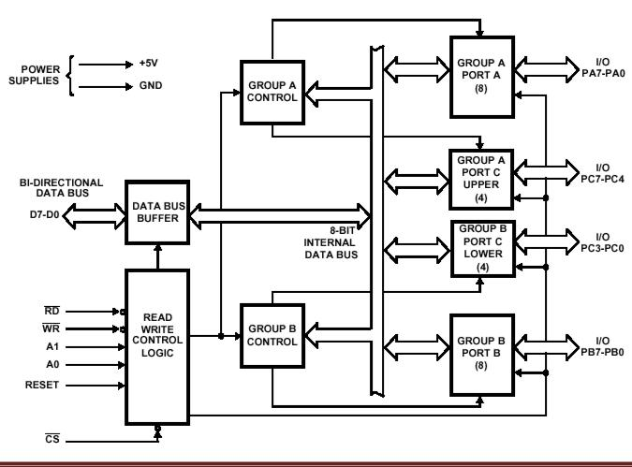

Data Bus Buffer

- This tri-state bidirectional 8-bit buffer is used to interface 8255A to the system data bus.

- Data, control words and status information are transferred through data bus buffer.

Read/Write Control Logic

- The function of this block is to manage all the internal and external transfer of both data and control words.
- It has six lines:

- ̅̅̅̅RD (Read): When the signal is low, the MPU reads data from the selected I/O port of 8255A.

- ̅̅̅̅̅ WR(Write): When the signal is low, the MPU writes data into the selected I/O port or writes control word into control register.

- RESET (Reset): This is an active high signal. It cleans the control register and set all ports in the input mode.
CS(Chip Select), A_{O} and A₁: These are the device select signals. ̅̅̅ is connected to decoded address; A_{O} and A₁ are generally connected to MPU address lines A_{O} and A₁ respectively.
If CS=0, 8255A is selected and if CS=1, 8255A is not selected. A_{O} and A₁ specify the selection of I/O ports as shown below.

A₁ | A_{O} | Port Selected
0 | 0 | Port A
0 | 1 | Port B
1 | 0 | Port C
1 | 1 | Control Register

Group A and Group B Controls

- Each of the control blocks accepts commands from read/write control logic and issues proper command to its associated ports.
Group A Control: Port A and Port C Upper
Group B Control: Port B and Port C Lower

I/O Ports

- The 8255A has 24 I/O pins that are grouped into three 8-bit parallel I/O ports: Port A (PA) Port B (PB) and Port C (PC)

- The 8-bit of port C can be used as individual bits or grouped into two 4-bit ports: Port C Upper (PC_{U}) and Port C Lower (PC_{L})
- The functions of I/O ports are defined by writing a control word into control register.

CONTROL WORD OF 8255A

8255A consists of 8-bit control register as shown in figure below. The content of control register is called control word. The control word specifies an I/O function for each port. Control register can be accessed to write control word when A₀=1 and A₁=1. Control register is not accessible for read operation.

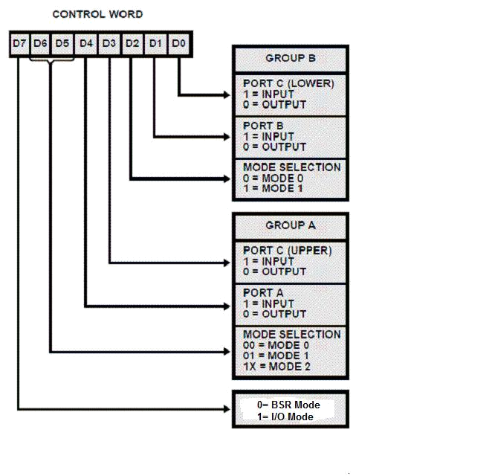
Derive a control word for 8255A to configure:

Port A= i/p port

Port B= o/p port

Port C Lower= i/p port

Port C Upper= o/p port

In simple I/O mode with Group A in mode 0 and Group B in mode 1.

Solution:

Control Word = 1 0 0 1 0 1 0 1 =10010101

= 95H

8255A MODES OF OPERATION

8255A consists of two modes of operation.

- I/O Mode (Input/Output Mode)
- BSR Mode (Bit set/reset Mode)

The BSR mode is used to set or reset the bits in Port C. The I/O mode is further divided into three modes: Mode 0, Mode 1 and Mode 2.

Mode 0: Simple Input or Output Mode

In this mode, ports A and B are used as two simple 8-bit I/O port and port C as two 4-bit ports. Each port can be programmed to function simply as input port or output port. The I/O features in Mode 0 are:

- Output are latched
- Inputs are not latched
- Ports do not have handshake or interrupt capacity

Mode 1: Input or Output with Handshake

In this mode, handshake signals are exchanged between the MPU and peripherals during data transfer. The features of this mode are:

- Two ports PA and PB function as 8-bit I/O ports. They can be configured either as input or output.

- Each port PA and PB uses three lines from Port C as handshake signals. The remaining two lines of PC can be used for Simple I/O function (mode 0).

- Input and Output data are latched.
- Interrupt logic is supported.

Mode 2: Bidirectional Data Transfer

- This mode is used primarily in applications such as data transfers between two computers.

- In this mode Port A can be configured as the bidirectional port (data bus) and Port B either in mode 0 or mode 1.

- Port A uses five signals from Port C as handshake signals for data transfer. The remaining three signals form Port C can be used as Simple I/O or as handshake for Port B.

BSR Mode (Bit Set/Reset)

- The BSR control word is only connected with 8-bits of Port C, which can be set or reset by writing appropriate control word in the control register.

- I/O operations of port A and port B are not affected by a BSR control word.

- In BSR mode, individual bits of port C can be used for applications such as ON/OFF switch.
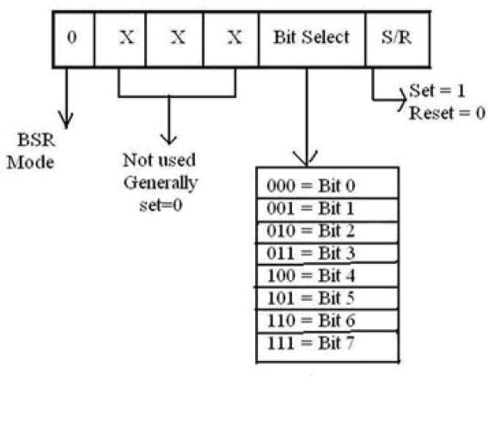

Fig: BSR Control Word

Q. Generate BSR control words to set bit PC₇ and PC₃ and reset PC₀ and PC_{2.}

Solution:
Control Word to Set PC₇=
Control Word to Set PC₇= | 0 | 0 | 0 | 0 | 1 | 1 | 1 | 1
= 00001111
=0FH
Control Word to Set PC₃= 00000111

= 07H
Control Word to Reset PC₀= 00000000

- 00H
Control Word to Reset PC₂= 00000100

=04H

DMA CONTROLLER

DMA (Direct Memory Access) and 8237 DMA CONTROLLER

- Direct memory access is an I/O technique commonly used for high speed data transfer.

- In DMA, the MPU releases the control of the buses to a device called DMA controller.

- The controller manages the data transfer between memory and peripherals under its control, thus bypassing the MPU.

- For all practical purposes, DMA controller is a processor capable of copying data at high speed from one location to another location.

THE 8237 DMA CONTROLLER

- The 8237 is a programmable DMA controller used as a peripheral interface circuit for microprocessor system.

- It is designed to improve system performance by allowing external devices to directly transfer information to or from system memory. Memory to memory transfer capability is also improved.

- It has four independent channels with each channel capable of transferring 64K bytes.

- The 8237 is designed to be used in conjunction with external 8-bit address register such as 8282.
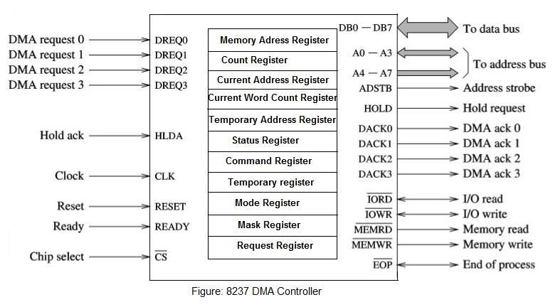

- 8237 is a complex device. We can study its properties under two sections: DMA Channels and DMA Signals.

DMA Channels

- 8237 has four DMA Channels: CH0 to CH3
- Two 16-bit registers are associated with each channel.
- Memory Address Register: used to load starting address of byte to be copied

- Count Register: used to load the count of number of bytes to be copied.
- The address of these register are determined by four address lines A₃ to A₀

A3 | A2 | A1 | A0 | Channel | Register
0 | 0 | 0 | 0 | CH0 | Memory Address Register
0 | 0 | 0 | 1 | CH0 | Count Register
0 | 0 | 1 | 0 | CH1 | Memory Address Register
0 | 0 | 1 | 1 | CH1 | Count Register
and so on.

DMA Signals

  - DMA signals can be divided into two groups:
    - Signals required to interface with peripheral devices

    - Signals required to interface with MPU

- Signals required to interface with peripheral devices:

DREQ0-DREQ3 (DMA Request)

o These are four independent, asynchronous input signals to the DMA channels from peripheral devices.

o To obtain DMA service, a request is generated by activating the DREQ line of the channel.

DACK0-DACK3 (DMA Acknowledgement)

o These are output lines to inform the individual peripherals that a DMA request is granted.

- Signals required to interface with peripheral devices:

AEN (Address Enable) and ADSTB (Address Strobe)

o These are active high output signals that are used to latch a high order address byte from data lines to generate 16-bit address.

̅̅̅̅̅̅̅̅̅ (Memory Read) ̅̅̅̅̅̅̅̅̅̅̅ (Memory Write)

o These are output signals used during the DMA cycle to write and read from memory.

A₃-A₀ Address Lines

o These are bidirectional address lines.
o They are used to access various internal registers.

HRQ (Hold Request) and HLDA (Hold Acknowledgement)

o HRQ is an output signal used to request MPU to receive control of the system bus.

o After receiving the HRQ, the MPU completes the bus cycle and issues the HLDA signal.

DMA Transfer

The sequence of DMA transfer is as follows:
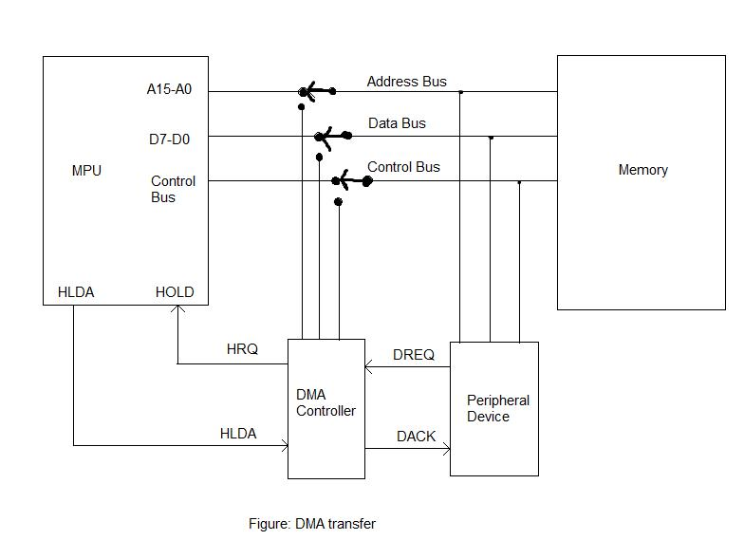

- The I/O devices request the DMA controller to perform DMA transfer through DREQ (DMA request) line.

- The DMA controller in turn sends a request signal (HRQ) to MPU through the HOLD line.

- The MPU finishes the current machine cycle and releases the system bus. It also acknowledges the receiving of HOLD signal through HLDA line.

- The DMA controller acquires control of the system bus. The DMA controller sends the DACK signal to the peripheral I/O and the DMA transfer begins.

- At the end of the transfer, the system bus is released by the DMA controller. The MPU takes control of the system bus and continues the operation.

DMA Operation

The 8237 is designated to operate in two major cycles. These are called Ideal and Active cycle.

A) Idle Cycle:

- When no channel is requesting service, the 8237 will enter the idle cycle. In this cycle the 8237 will sample DREQ lines every clock cycle to determine if

any channel is requesting DMA service. The device will also sample CS looking for an attempt by MPU to write or read the internal register of 8237.

- When CS ̅̅̅̅ is low and HRQ is low, the 8237 enters the program condition.
o Special software commands can be executed by 8237 in program condition.

- Active Cycle:

When the 8237 is in the idle cycle and channel requests a DMA service, the device will output an HRQ to the microprocessor and enter into the active cycle. In this cycle the DMA transfer occurs in one of the four modes:

  - Single Transfer Mode
  - Block transfer Mode
  - Demand Transfer Mode
  - Cascade Mode

Single Transfer Mode

- In this mode, the device is programmed to make one transfer only. o The word count will be decremented and the address decremented or

incremented following each transfer.

Block Transfer Mode

- In this mode the device is activated by DREQ to continue making transfer during the service until Terminal Count (TC), caused by word count going to zero or an external End of Process (̅̅̅̅̅̅) is encountered.
Demand Transfer Mode
- In demand transfer mode the device is programmed to continue making
transfer until a TC or external ̅̅̅̅̅̅ is encountered or until DREQ line goes inactive.
- Thus transfer may continue until the I/O device has exhausted its data capacity. After the I/O device has had a chance to catch up, the DMA service is re-established by means of a DREQ.

Cascade Mode

- This mode is used to cascade more than one 8237 together for simple system expansion.

- The HRQ and HLDA signals from the additional 8237 are connected to the DREQ and DACK signals of a channel of the initial 8237.

HOLD
HOLDMPU |  |  |  |  |  | 8237
 | HOLD |  |  |  |  | HRQ
 | HOLD |  | HRQ | DREQ |  | HRQ
 | HLDA |  | HLDA | DACK |  | HLDA
 |  |  | 8237
 |  |  |  | DREQ |  | HRQ
 |  |  |  | DREQ |  | HLDA
 |  |  |  | DACK |  | HLDA
 |  |  |  |  | 8237
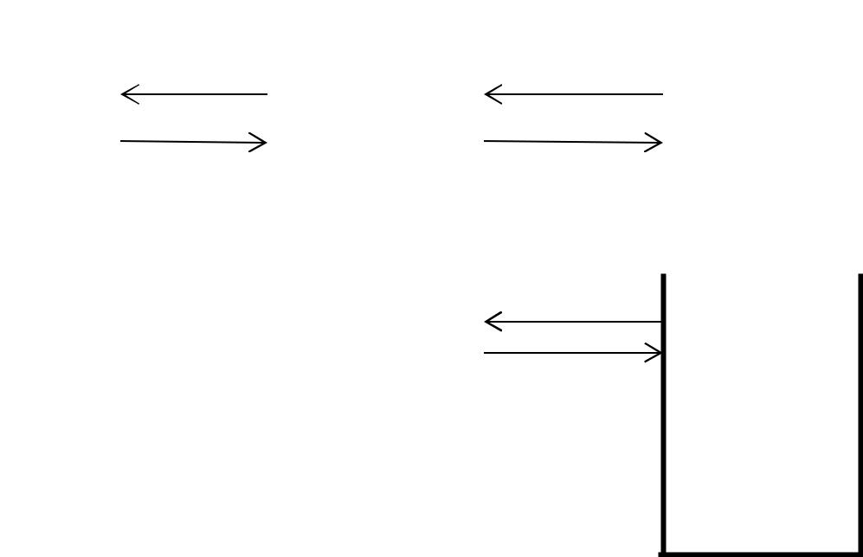

Figure: Cascaded connection of 8237

8251A UNIVERSAL SYNCHRONOUS ASYNCHRONOUS RECEIVER TRANSMITTER (USART)

The 8251A is a USART (Universal Synchronous Asynchronous Receiver Transmitter) for serial data communication. As a peripheral device of a microcomputer system, the 8251A receives parallel data from the CPU and transmits serial data after conversion. This device also receives serial data from the outside and transmits parallel data to the CPU after conversion.
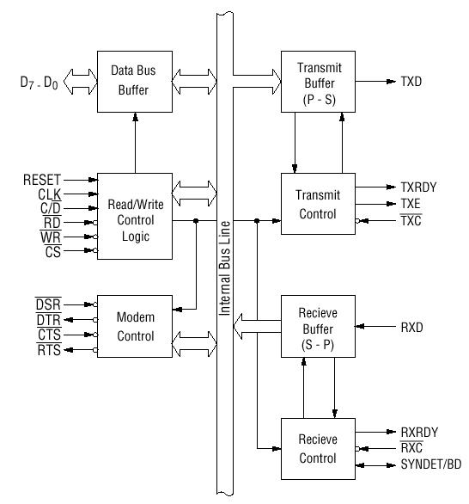

Figure: Block diagram of the 8251A USART

Data Bus Buffer

This 3-state bidirectional, 8-bit buffer is used to interface 8251A to the system data bus. Date is transmitted or received by the buffer upon execution of Input/Output instruction of CPU.

Read/Write Control Logic
This block contains following signals-

- RESET

A "High" on this input forces the 8251A into "reset status." The device waits for the writing of "mode instruction."

- CLK(Clock)
CLK signal is used to generate internal device timing.

- WR(Write)

This is the "active low" input terminal which receives a signal for writing transmit data and control words from the CPU into the 8251A.

- RD(Read)

This is the "active low" input terminal which receives a signal for reading receive data and status words from the 8251A.

- C/D (Command/Data)

This is an input terminal which receives a signal for selecting data or command words and status words when the 8251A is accessed by the CPU. If C/D = 0, data will be accessed. If C/D = 1, command word or status word will be accessed.

- CS (Chip Select)

This is the "active low" input terminal which selects the 8251A at low level when the CPU accesses.

Modem Control

The 8251A has the set of control inputs and outputs that can be used to simply interface to almost any modem. This block has following signals-

- DSR (Data Set Ready)

This is an input port for MODEM interface. The input status of the terminal can be recognized by the CPU reading status words.

- DTR (Data Terminal Ready)

This is an output port for MODEM interface. It is possible to set the status of DTR by a command.

- CTS (Clear to Send)

This is an input terminal for MODEM interface which is used for controlling a transmit circuit. The terminal controls data transmission if the device is set in "TX Enable" status by a command. Data is transmittable if the terminal is at low level.

- RTS (Request to Send)

This is an output port for MODEM interface. It is possible to set the status RTS by a command.

Transmit Buffer

The Transmit Buffer accepts parallel data from the Data Bus Buffer, converts it to serial bit stream, inserts the appropriate character or bits and outputs a serial stream of data on the TXD output pin.

Transmit Control

The Transmit Control manages all the activities associated with the transmission of serial data. It has following signals-

- TXRDY (Transmitter Ready)

This is an output terminal which indicates that the transmitter is ready to accept a data character.

- TXE(Transmitter Empty)

This is an output terminal which indicates that the 8251A has transmitted all the characters and had no data character.

- TXC (Transmitter Clock)
The Transmitter Clock controls the rate at which the character is to be transmitted.

Receive Buffer

The Receive Buffer accepts serial data, converts this serial data to parallel format and sends to the CPU. Serial Data is input to RXD pin.

Receive Control

This functional block manages all receiver-related activities and consists of following signals-

- RXRDY (Receiver Ready)

This is a terminal which indicates that the 8251A contains a character that is ready to ready by CPU.

- RXC (Receiver Clock)
This is a clock input signal which determines the transfer speed of received data.

- SYNDET/BD (SYNC detect/ Break Detect)

This pin is used in Synchronous Mode for SYNDET and may be used as either input or output and is programmable through the Control Word. In Asynchronous mode it can be used for BD which goes HIGH whenever the receiver remains low through two consecutive stop bits.

CONTROL WORDS
There are two types of control word.

- Mode instruction
- Command

1) Mode Instruction

The bit configuration of mode instruction is shown in Figures 2 and 3. In the case of synchronous mode, it is necessary to write one-or two byte sync characters. If sync characters were written, a function will be set because the writing of sync characters constitutes part of mode instruction.

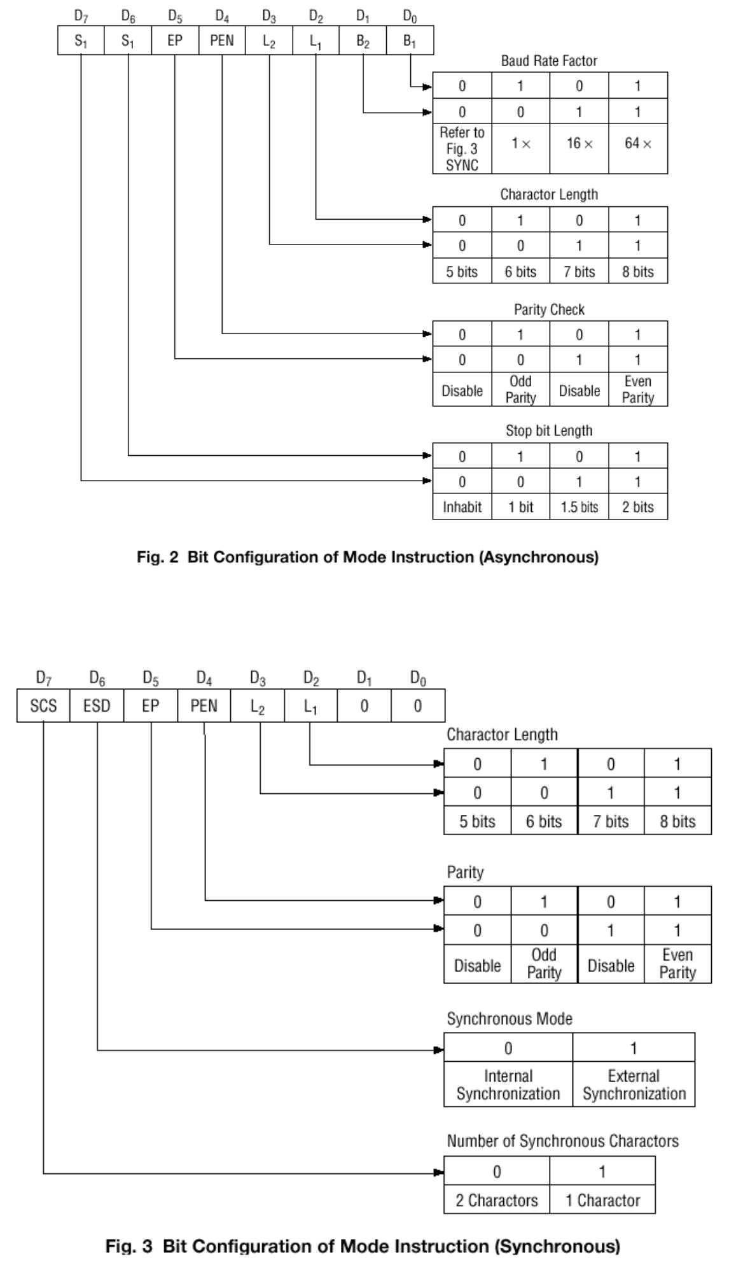

2) Command

Command is used for setting the operation of the 8251A. It is possible to write a command whenever necessary after writing a mode instruction and sync characters.
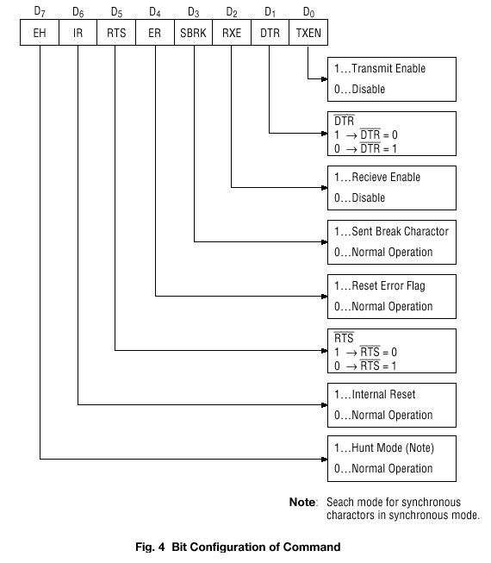

STATUS WORD

It is possible to see the internal status of the 8251A by reading a status word. The bit configuration of status word is shown in Fig. 5.
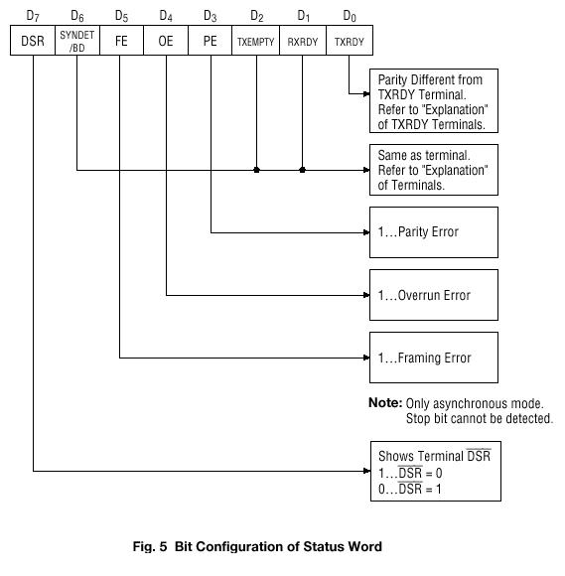

Programmed I/O Vs Interrupt driven I/O
Programmed I/O
Programmed I/O (PIO) refers to data transfers initiated by a CPU under driver software control to access registers or memory on a device.
The CPU issues a command then waits for I/O operations to be complete. As the CPU is faster than the I/O module, the problem with programmed I/O is that the CPU has to wait a long time for the I/O module of concern to be ready for either reception or transmission of data. The CPU, while waiting, must repeatedly check the status of the I/O module, and this process is known as Polling. As a result, the level of the performance of the entire system is severely degraded.
Programmed I/O basically works in these ways:
- CPU requests I/O operation
- I/O module performs operation
- I/O module sets status bits
- CPU checks status bits periodically
- I/O module does not inform CPU directly
- I/O module does not interrupt CPU
- CPU may wait or come back later
Interrupt driven I/O
The CPU issues commands to the I/O module then proceeds with its normal work until interrupted by I/O device on completion of its work.
For input, the device interrupts the CPU when new data has arrived and is ready to be retrieved by the system processor. The actual actions to perform depend on whether the device uses I/O ports, memory mapping.
For output, the device delivers an interrupt either when it is ready to accept new data or to acknowledge a successful data transfer. Memory-mapped and DMA-capable devices usually generate interrupts to tell the system they are done with the buffer.
Although Interrupt relieves the CPU of having to wait for the devices, but it is still inefficient in data transfer of large amount because the CPU has to transfer the data word by word between I/O module and memory.

Below are the basic operations of Interrupt driven I/O:
- CPU issues read command
- I/O module gets data from peripheral whilst CPU does other work
- I/O module interrupts CPU
- CPU requests data
- I/O module transfers data
